Name & Student ID
Maximilian Lee
20363479

Title
System manual for robot plotter text writer project

Software Description
The purpose for this program is to read text from a text file (“InputText.txt”) and use the font data in another text file (“FontData.txt") to generate GCode and send the GCode to a robot pen plotter to be written.
The program first prompts the user to enter a fontsize
The program then calls a function (Function 1) that opens the font data file and counts the number of characters it gives data for. The function will return an error if the font data file is incorrectly formatted with the stated length of the character data being different to the actual length.
The program then calls another function (Function 2) which reads the font data into X, Y and Pen arrays and stores them in structs. The structs are stored in an array in order of their ASCII codes.
Another function (Function 3) is called once for each character which re-sizes the X and Y arrays to the font size
Another function (Function 4) then opens the input text file and counts the number of words
The rest of the program is in a for loop which repeats once for each word in the input text file. The loop reads each word, calculates its origin, calculates the origin for each letter in the word and generates GCode which it sends to the buffer line by line.

Project Files
(Maximum 1 page)

Key Data Items

Name | Data type | Rationale
PageWidth | int | The width of the page == 100
LineGap | int | The gap between the bottom of the word on one line and the top of the word on the next line == 5
FontSize | int | The size of the letters in mm given by the user
Characters | Struct | A struct containing an integer of the ASCII for that character, the length of the font data and arrays for the X position, Y position and Pen position
CharacterArray | Struct array | An array of structs, one for each character.
WordCount | int | The number of words in the input text file.
SkipCount | int | This is the number of letters that need to be skipped in the input text file to get to the start of the word being read
WordCharacterCount | int | The length of the word being read
WordArray | int | A dynamically allocated array containing the ASCII for the letters in that word (If there is a space or newline before the word that is included in the array, the word ends before the space/newline after it)
NewLineCountIn | int | This is a count of how many newline (ASCII 10) are at the start of the word
NewLineCountOut | int | This is zero unless the word would go off the edge of the page (X>100) in which case it is 1
OldWordEndXY | Int array | A 2x1 array containing the X and Y position of the end of the last word
NewWordStartXY | Int array | A 2X1 array containing the X and Y position of the start of the new word
LetterOriginArray | Int array | An array 2XWordCharacterCount containing the X and Y positions of each letter origin for the word being read

Functions
Function 1 – Count the font data letters
Description – Function is sent the name of the font data text file. It opens the file and counts how many characters the file has data for. It then sends this number to the pointer “count”
int F_CountLetters(char* FontData, int *count)
Parameters:
char* FontData – The name of the text file with the supplied font data
int *count – A pointer address for the number of letters in the font file
Return value – returns 0 if successful, 1 if failed

Function 2 – Puts font data into structs
Description – Function is sent the name of the font data text file and the number of characters “count”. It reads the font data for each character into X position, Y position and Pen position arrays and stores these arrays in a struct with the length of the arrays “length” and the ASCII code for each character “ascii”. These structs are then put in an array and sent to the **ReturnArray
int F_FontDataToStruct(char* FontData, Characters **ReturnArray, int count)
Parameters:
char* FontData – The name of the text file with the supplied font data
Characters **ReturnArray – A pointer to the array of structs
int count – number of letters in the font file
Return value – returns 0 if successful, 1 if failed

Function 3 – Resizes the font data in each struct
Description – Function resizes the font data for the character it is sent
int F_ResizeStructs(int FontSize, Characters Character)
Parameters:
int FontSize – The size of the font in mm (4 - 10)
Characters Character - the struct containing the font data for the letter sent to the function
Return value – returns 0 if successful, 1 if failed

Function 4 – counts the number of words
Description – opens the input text file and counts the number of words. A word is defined as some text (not ASCII 32 or 10) bookended by a space, newline, start of file or end of file
int F_CountWords(char* InputText, int *WordCount)
Parameters:
char* InputText – The name of the text file with the input text
int *WordCount – The number of words in the intup text file
Return value – returns 0 if successful, 1 if failed

Function 5 – Counts skip characters
Description – counts the number of characters before the word being read
int F_CountSkipCharacters(char* InputText, int Word, int *SkipCount)
Parameters:
char* InputText – The name of the input text file
int Word – The number of the word being read (1 for first word)
int *SkipCount – The number of characters before the word being read
Return value – returns 0 if successful, 1 if failed

Function 6 – Make an ASCII array for the word
Description – Function opens the input text file and skips over the characters before the word. It then reads each character of the word into an array
int F_ReadWordToASCIIArray(char* InputText, int Word, int **WordArray, int SkipCount, int *WordCharacterCount)
Parameters:
char* InputText – The name of the input text file
int Word – The number of the word being read (1 for first word)
int **WordArray – A dynamically allocated array containing the ASCII for the letters for the word being read in order
int SkipCount – The number of characters before the word being read
int *WordCharacterCount – The number of characters in the word being read
Return value – returns 0 if successful, 1 if failed

Function 7 – Finds the word origin
Description – Function decides where the word origin is. If the word starts with a newline (ASCII 10) it send the word to a newline. If not it checks if the word will overspill the page and if so sends it to a new line. If not it sets NewXY = OldWordEndXY
int F_FindWordOrigin(int PageWidth, int LineGap, int* OldWordEndXY, int* WordArray, int LengthWordArray, int FontSize, int* NewXY, int *PtrNewLineCountIn, int *PtrNewLineCountOut)
Parameters:
int PageWidth – The width of the page == 100
int LineGap – The gap between lines == 5
int* OldWordEndXY – a 2X1 array containing the X and Y of the end of the previous word
int* WordArray –An array containing the ASCII for the letters for the word being read in order
int LengthWordArray – The number of characters in the word being read
int FontSize – The size of the letters in mm
int* NewXY – a 2X1 array containing the X and Y of the start of the word being read
int *PtrNewLineCountIn – how many newline (ASCII 10) are at the start of the word
int *PtrNewLineCountOut – 1 if the word goes off the edge of the page X>100
Return value – returns 0 if successful, 1 if failed

Function 8 – Finds letter origins
Description – Makes an array containing the X and Y for the origin of each letter in the word
int F_FindLetterOrigin(int PageWidth, int LineGap, int* WordArray, int LengthOfArray, int FontSize, int* NewWordStartXY, int *LetterOriginArray[], int NewLineCountOut, int NewLineCountIn)
Parameters:
int PageWidth – The width of the page == 100
int LineGap – The gap between lines == 5
int* WordArray – An array containing the ASCII for the letters for the word being read in order
int LengthOfArray – The number of characters in the word being read
int FontSize – The size of the letters in mm
int* NewWordStartXY – a 2X1 array containing the X and Y of the start of the word being read
int *LetterOriginArray[] – An array containing the X and Y for the origin of each letter in the word
int NewLineCountOut – how many newline (ASCII 10) are at the start of the word
int NewLineCountIn – 1 if the word goes off the edge of the page X>100

Testing Information

Function | Test Case | Test Data | Expected Output
main | To see if the program can write to a new line if the line of input text would overspill the page width | FontSize = 6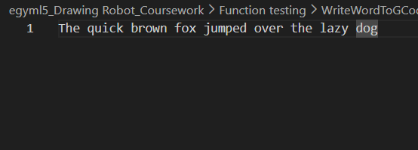 | 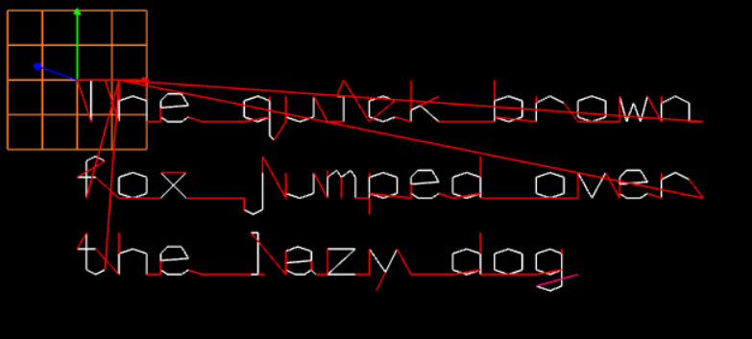
main | To see if the program can write to a new line where the input text has a new line | FontSize = 6  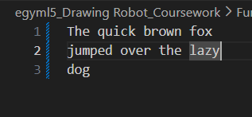 | 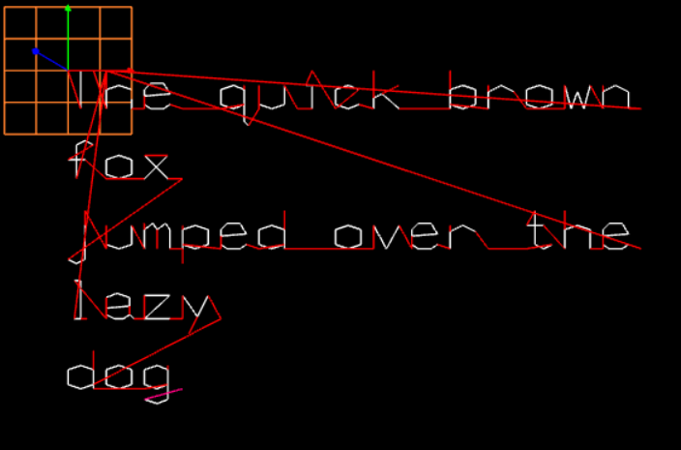
main | To see if the program will go to a newline mid-word if the word is longer than the page width | FontSize = 6  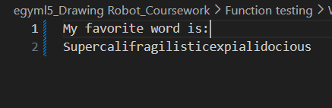 | 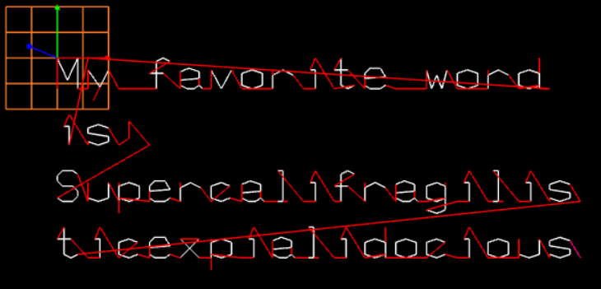
main | To see if the program is re-sizing fonts correctly | FontSize = 4  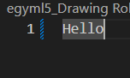  FontSize = 10 | 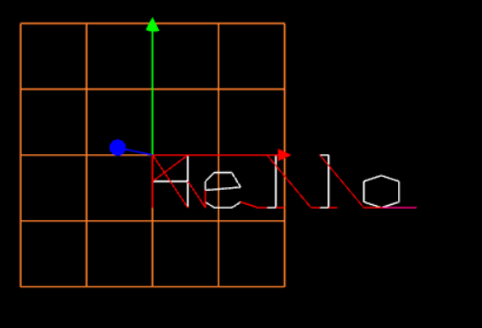  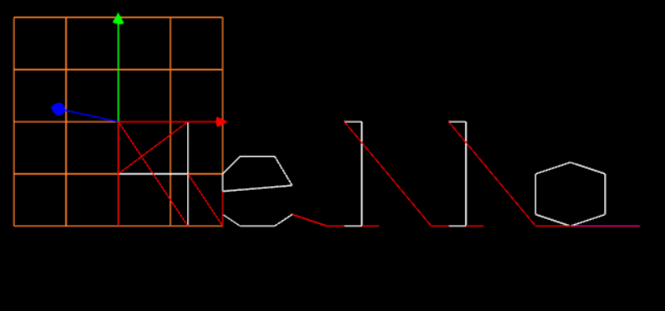
Function 1 | To see if it counts the number of characters in the font data file correct | Call the function with the font data file correctly formatted | ReturnVal1 = 0  Count = 128
Function 1 | To see if it notices if the font data file is incorrectly formatted | Call the function with the font data file incorrectly formatted | ReturnVal1 = -1  Count = N/A  printf(Font data incorrectly formatted")
Function 2 | To see if it correctly reads and stores the font data | Run Function 1 and 2 then loop function F_DisplayCharacter  For every element of the CharacterArray | Print the data for each letter as an X Y and Pen array
Function 3 | To see if it correctly re-sizes the X and Y arrays | Run Function 1, 2 and 3 then loop function F_DisplayCharacter  For every element of the CharacterArray | Print the data for each letter as an X Y and Pen array with the X and Y array values correctly resized to the font size
Function 4 | To see if it correctly counts the number of words | Write a sentence in the input text file then run Function 4 and print WordCount | Prints the correct number of words

AI Statement
No AI was used to write this system manual
ChatGPT was used in the creation of the program as a debugging tool to help understand the error messages.

Flowchart(s)
